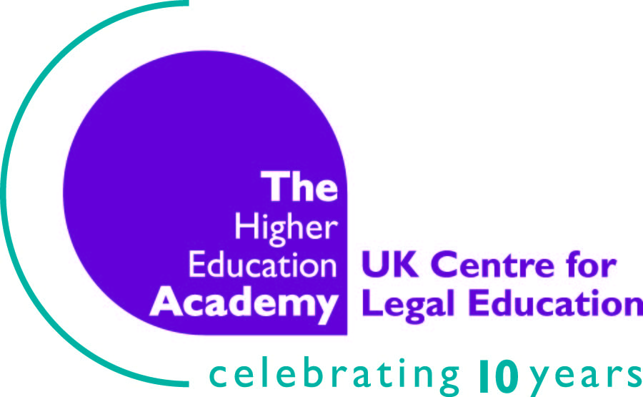

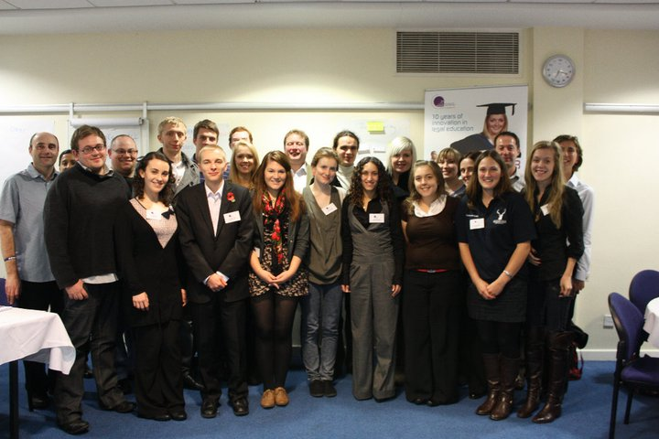
Photograph by Felicia Kyrk
The National Law Students Forum
3-4 November 2010
Manchester Conference Centre

Report by
Imogen Canavan, Undergraduate Student
Kent Law School

Introduction
The Higher Education Academy (HEA) is an independent organisation that supports higher education institutes throughout the United Kingdom. It aims to ‘support the sector in providing the best possible learning experience for all students’. With twenty-four discipline-based subject centres, the HEA provides services to subject departments, including law under the UK Centre for Legal Education (UCKLE).
The UKCLE is based at the University of Warwick. It aims to develop and promote the learning and teaching of law at academic and vocational stages.
The National Law Students Forum 2010 (the Forum from herein) was a pilot event attended by twenty law students from twenty different universities across England, Scotland and Wales. The Forum objective was to demonstrate how students can actively develop their contribution to the learning process. It was held at the Manchester Conference Centre over two days in November 2010.
This report will consider what was discussed at the Forum, comment on, amongst other things, the systems in place at the University of Kent’s Law School in relation to other universities and make suggestions in relation to improving the educational experience at the University of Kent.

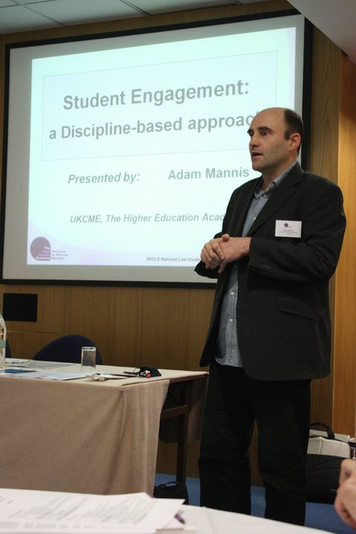
The National Law Students Forum
The Forum commenced with a brief introduction from the Senior Teaching and Learning Advisor at UKCLE, Patricia McKellar. She welcomed us to the Forum and informed us about the HEA and UCKLE.
Patricia was succeeded by Adam Mannis, who spoke about ‘The Experience of Other Disciplines’. Adam is Assistant Director at the UK Centre for Materials Education, based at the University of Liverpool. He discussed a discipline-based approach to student engagement institutionally, departmentally and regionally. The difficulty of encouraging students to be more active, and to change and develop the curriculum was also considered. This appeared to be a common problem at the represented institutions. In relation to student representatives, Adam emphasised the importance of developing subject specific training for student representatives to explain processes and techniques tailored to representing law students. Training to be a law student representative would further empower the student representatives. Once elected and trained, the importance of acting credibly with staff was highlighted in order to represent the student body effectively. It was agreed that to act credibly, the student representatives must negotiate and influence staff in a proper manner. The students thought it would be a good idea for the student representatives to create a report for their university on how to gather feedback and student views from a cohort of students. It is important that students know how to gather and make sense of student feedback. One of the final points Adam spoke about was the value of the academic research which takes place at our institutions, and he emphasised that students should be made more aware of this.
Adam Mannis speaking at the Forum.


Then there was an ‘icebreaker’ session for both the students and staff. We stood in circles of about ten to fifteen students, with one person in the middle. The person in the middle of the circle had to say something about himself or herself on a topic given to us, for example about our university. Everyone in the circle who felt that the statement was true in their own context, had to swap places with another person who felt it was also true. The person left without a place who was trying to swap places then had to go into the middle and would start again with a new statement. This game allowed the students to relax and to get to know other students from other institutions.
Icebreaker session.
The final session on the first day was by Ant Bagshaw from the National Union of Students regarding ‘Effective Representation’. This included discussions on building up credibility to increase the authority of student representatives amongst staff. Students made suggestions of informal engagement such as going for coffee with staff, inviting them to law society socials, sharing common rooms and sending emails. Then we discussed structured informal engagement such as mentor schemes, individual work with academics, student engagement conferences and student journals in more detail. In relation to mentoring schemes, some students felt that part time and mature students were more isolated than other students. It was suggested that social events specifically for mature students would help to remedy this. To further the support to students, at one university, the law society allocated a second year or third year student to ‘adopt’ a handful of first years based on their common interests. The student said that this was a very successful scheme.

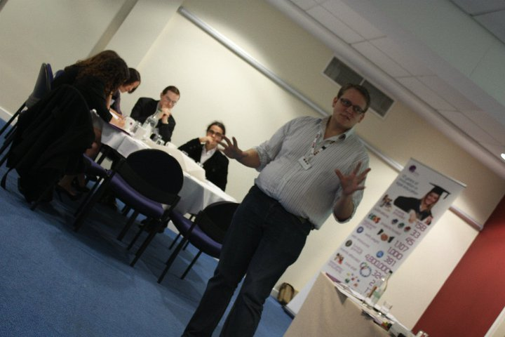
Informal engagement by individual voluntary work with an academic was also discussed. This included pro bono work, working with the police, representing students and mentoring alongside staff. The skills that students may gain from such experiences may include interviewing, research, networking and negotiating skills. One issue that may arise from individual voluntary work with an academic is the credibility of such work. Ant suggested to increase the credibility of such a project is to involve groups such as other staff/students, societies and other entities. It was also suggested that students may engage informally with staff by the means of a conference. A conference could involve groups such as students, staff academics and others, and may target; non-law students in relation to a career in law, law graduates regarding careers in law that aren’t the typical routes or would be mature students. This would raise awareness of the value of a law degree, and would provide for students who aren’t able or don’t want to become a qualified lawyer. The final method of informal engagement we discussed was a student journal. One advantage of such a project is the vast number of people you may involve such as, but not excluded to; staff, students, alumni, firms and societies. Financial difficulties can be avoided by the use of technology to make a pdf version, put it on the website, on Facebook, in a blog format, as an application for the i-phone or as a podcast. All of the methods of informal engagement that we discussed increase the credibility of students and it is important that students are aware of the importance of doing so.
Ant Bagshaw speaking at the Forum.

Day two

On the second day of the Forum, the first session was an open session for students to discuss key issues in learning and teaching practices in law. Several issues were considered, in particular the legal curriculum, careers advice and the quality of teaching. Students felt that the legal curriculums at their institutions were too narrow (although this was not a main priority) and that teaching styles could be improved. Students felt that video casts would be highly beneficial. Considering careers advice, students felt that there was a lack of advice on non-legal career and not typical careers for law graduates. It was also suggested that students should be taught business professional skills and that seminars taught in a mooting format would be favourable.
The Forum moved on to group sessions with plenary feedback. Everyone was given two post-it notes and each student had to write down a first priority on a post-it note and a second priority on the other. These were then collated and students divided into groups to discuss some of the main issues raised by the student’s priorities. The main issues that were raised were careers advice, teaching quality and skills.
Plenary Feedback
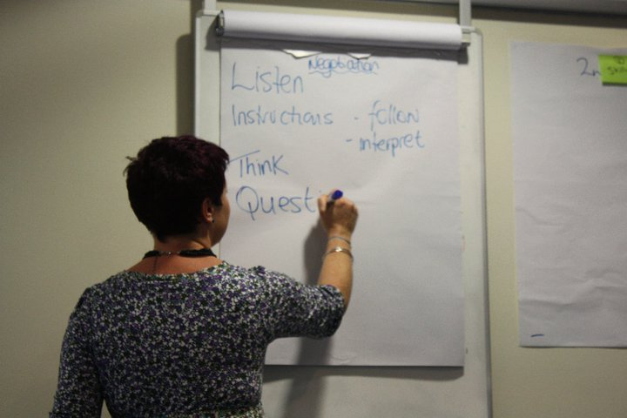
The third session of the day was the “communications and negotiation skills workshop” by Rebecca Huxley-Binns. Rebecca is a Reader in Law at Nottingham Trent University. Her session was very interactive and stimulating. Students discussed the importance of communication in the legal sector. Rebecca said that ‘words are a lawyers tool’. She highlighted barriers in practicing law such as working with friends and enemies, and the emotional impact that cases may have on a practitioner. She explained that body language plays an important role in communication and using key words such as ‘if’ which allows you to hypothesise, and ‘because’ which allows to explain why and reason. Rebecca emphasised the importance of communication in relation to networking. Her networking top tips included saying someone’s name when greeting them, taking notes of what you know about people (which I have subsequently found particularly useful on my second internship in the same office) and soft skills, such as eye contact and slow speech. The students then carried out a negotiation exercise. We were divided in pairs, and were each given a scenario and party to represent. We then sat back-to-back (because lawyer-client correspondence happens over the phone or via email now) and began to negotiate on behalf of our clients. This exercise allowed us to take in facts quickly, communicate with another party, while considering what information to disclose and withhold, and encouraged us to predict outcomes and form back-up plans. The exercise encouraged students to practice skills which are vital in becoming a good legal practitioner.
Rebecca speaking at the Forum.
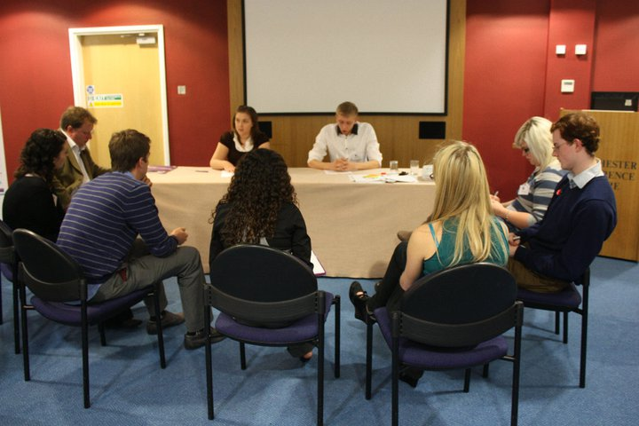
We ended the conference with a “simulated staff student meeting” session. This session was run by Michael Bromby, who is a Reader in Law at Glasgow Caledonian University. The students were divided into large groups, and two were elected to be student representatives in the role-play, and the rest were staff. The student representatives were given a problem, which had been raised by the student cohort at their imaginary institution. After coming up with a strategy and back-up plan of how to approach the staff in the meeting in relation to the issue, we began the role-play. Most student representatives were able to compromise with the staff in the role-play, however the student representatives had to keep realistic aims. Within the role-play scenarios two suggestions were made; to make more specific feedback forms on assessments and for student to organise a small booklet of key terms which new students are unlikely to know until they have embarked on their law degree.
A simulated staff/student meeting.
To conclude the Forum was, in my opinion highly successful. The students that attended the event were highly engaged in all of the sessions and there was a great atmosphere amongst the students and staff. The structure of the Forum proved that the points raised about informal engagement to be true as we found the refreshments, dinners and train journey discussions with both students and staff resulted in progressive and beneficial discursive outcomes. The students that attended the Forum have stayed in contact via online forums, facebook and emails. One benefit that the students hoped would come out of the Forum is that we would begin to form a network between the universities that attended the conference and their representatives. The staff at the Forum mentioned future plans to hold another Forum next year.

Conclusion
In my opinion the Forum highlighted the strengths that KLS has in its existing systems, schemes and societies. I hope that this report has provided some useful information to staff and students at KLS and that the suggestions that I have made will be considered.
I would also like to thank KLS for the opportunity to attend the Forum. I found the event very informative and thought provoking. I thoroughly enjoyed the Forum and I would recommend to KLS that they take the opportunity to send another student in the future if possible should another Forum be scheduled.



The Higher Education Academy, 'Strategic Plan 2008-13' (Report) (2008)

